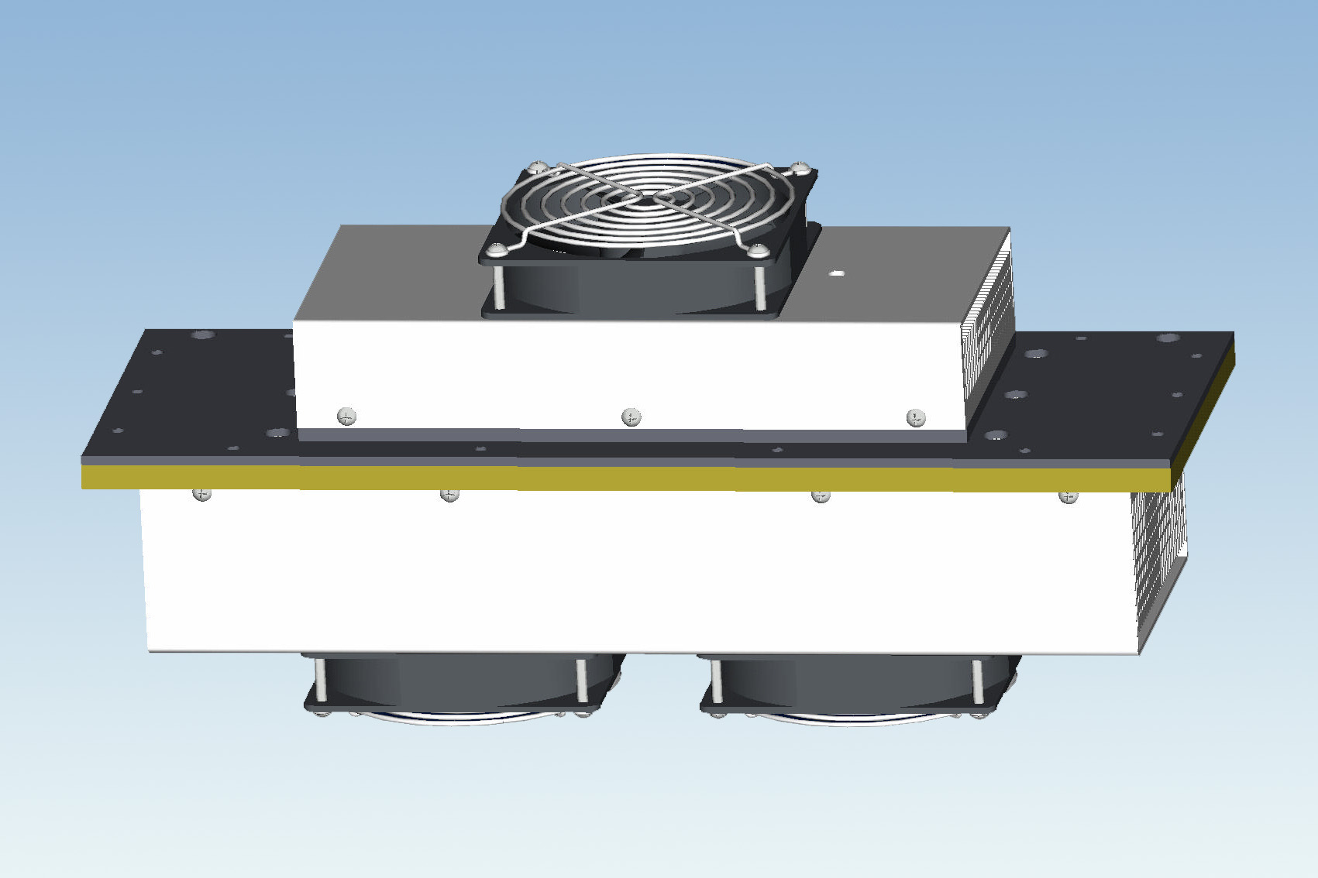 |  |  | NM-AA750-24  Specification  Cooling Capacity  750 BTU/Hr  Input Power  24 VDC  Current  8.5 A  Weight  8.2 Kg (18.2 lbs)  Max Operating Temp.  60 Degree C  Reliability Data  MTBF of TE modules  200,000 Hrs  MTBF of Cooling Fans  50,000 Hrs

Model Number Nomenclature
NM – A A 750 - 24

DC Voltage (V)

Capacity (BTU/Hr)
Ambient Side - Air
Cabinet Side - Air

Generic
 |  |  | Performance Curve
Power Connector

Installation Cutout
mm (inch)
Position
Description

1
TEC +

2
TEC -

3
TEC +

4
TEC -

5
TEC +

6
TEC -

7
FAN +

8
FAN -

Dimensional Drawing
mm(inch)

